Motion N30

# Question 1

what is A in the following reaction ?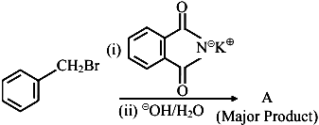

1. 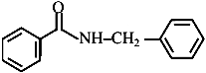
2. image
3. 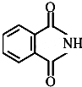
4. image

# Question 2

Which one of the products of the following reactions does not react with Hinsberg reagent to form sulphonamide? [25 Jul 2021]

1. 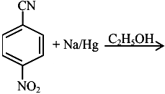
2. 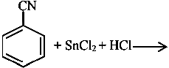
3. 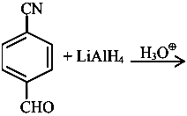
4. 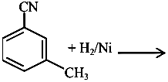

# Question 3

An organic compound "A" on treatment with benzene sulphonyl chloride gives compound $B.B$ is soluble in dil. $NaOH$ solution. Compound $A$ is______________.

$C_{6}H_{5}-N-{\left({CH}_{3}\right)}_{2}$

$C_{6}H_{5}-{NHCH}_{2}{CH}_{3}$

$C_{6}H_{5}-{CH}_{2}{NHCH}_{3}$

$C_{6}H_{5}-CH-{NH}_{2}$

# Question 4

The total number of reagents from those given below, that can convert nitrobenzene into aniline is _______________ (Integer answer)

|  |  |
| --- | --- |
|  |  |
|  | Raney nickel |

# Question 5

Match List I with List II.

| List-I | List-II |
| --- | --- |
| A. Benzenesulphonyl Chloride | I. Test for primary amines |
| B. Hoffmann bromamide reaction | II. Anti Saytzeff |
| C. Carbylamine reaction | III. Hinsberg reagent |
| D. Hoffmann orientation | IV. Known reaction of Isocyanates |

Choose the correct answer from the options given below:

1. A-IV, B-III, C-II, D-I
2. A-IV, B-II, C-I, D-II
3. A-III, B-IV, C-I, D-II
4. A-IV, B-III, C-I, D-II

# Question 6

The major product formed in the following reaction is.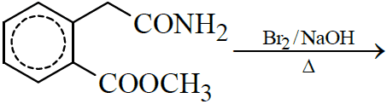

1. 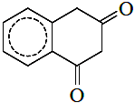
2. 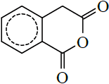
3. 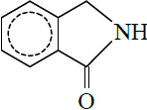
4. 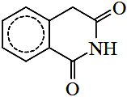

# Question 7

Choose the correct colour of the product for the following reaction.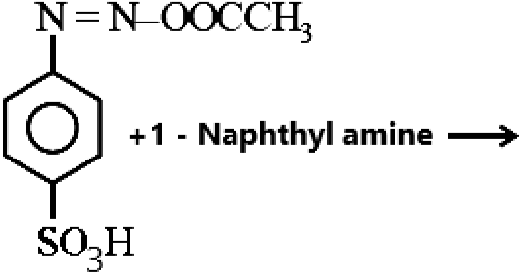

1. Yellow
2. White
3. Red
4. Blue

# Question 8

The correct order in aqueous medium of basic strength in case of methyl substituted amines is :

${Me}_{2}NH>{MeNH}_{2}>{Me}_{3} N>{NH}_{3}$

${Me}_{2}NH>{Me}_{3} N>{MeNH}_{2}>{NH}_{3}$

${NH}_{3}>{Me}_{3} N>{MeNH}_{2}>{Me}_{2}NH$

${Me}_{3} N>{Me}_{2}NH>{MeNH}_{2}>{NH}_{3}$

# Question 9

Number of isomeric aromatic amines with molecular formula $C_{8}H_{11} N$, which can be synthesized by Gabriel Phthalimide synthesis is ___________.  [6-Apr-2023]

# Question 10

The decreasing order of basicity of the following amines is: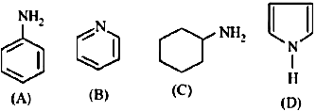

$\left(A\right)>\left(C\right)>\left(D\right)>\left(B\right)$

$\left(C\right)>\left(A\right)>\left(B\right)>\left(D\right)$

$\left(B\right)>\left(C\right)>\left(D\right)>\left(A\right)$

$\left(C\right)>\left(B\right)>\left(A\right)>\left(D\right)$

# Question 11

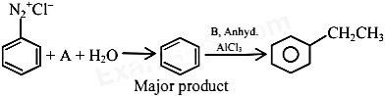the chemical reactions given above $A$ and $B$ respectively are:

1. $H_{3}{PO}_{2}$ and ${CH}_{3}{CH}_{2}Cl$
2. ${CH}_{3}{CH}_{2}OH$ and $H_{3}{PO}_{2}$
3. $H_{3}O_{2}$ and ${CH}_{3}{CH}_{2}OH$
4. ${CH}_{3}{CH}_{2}Cl$ and $H_{3}{PO}_{2}$

# Question 12

The number of nitrogen atoms in a semicarbazone molecule of acetone is_____________.

# Question 13

The total number of reagents from those given below, that can convert nitrobenzene into aniline is _______________ (Integer answer)

|  |  |
| --- | --- |
|  |  |
|  | Raney nickel |

# Question 14

Match List I with List II.

| List-I | List-II |
| --- | --- |
| A. Benzenesulphonyl Chloride | I. Test for primary amines |
| B. Hoffmann bromamide reaction | II. Anti Saytzeff |
| C. Carbylamine reaction | III. Hinsberg reagent |
| D. Hoffmann orientation | IV. Known reaction of Isocyanates |

Choose the correct answer from the options given below:

1. A-IV, B-III, C-II, D-I
2. A-IV, B-II, C-I, D-II
3. A-III, B-IV, C-I, D-II
4. A-IV, B-III, C-I, D-II

# Question 15

Given below are two statements :Statement I: Aniline reacts with con. $H_{2}{SO}_{4}$ followed by heating at $453-473 K$ gives p-aminobenzene sulphonic acid, which gives blood red colour in the ’Lassaigne’s test’.II: In Friedel - Craft’s alkylation and acylation reactions, aniline forms salt with the catalyst.to this, nitrogen of aniline aquires a positive charge and acts as deactivating group.the light of the above statements, choose the correct answer from the options given below :

1. Statement I is false but statement II is true
2. Both statement I and statement II are false
3. Statement I is true but statement II is false
4. Both statement I and statement II are true

# Question 16

In the reaction of hypobromite with amide, the carbonyl carbon is lost as

${CO}_{3}​^{2-}$

${HCO}_{3}​^{-}$

${CO}_{2}$

$CO$

# Question 17

The total number of reagents from those given below, that can convert nitrobenzene into aniline is _______________ (Integer answer)

|  |  |
| --- | --- |
|  |  |
|  | Raney nickel |

# Question 18

Match List I with List II.

| List-I | List-II |
| --- | --- |
| A. Benzenesulphonyl Chloride | I. Test for primary amines |
| B. Hoffmann bromamide reaction | II. Anti Saytzeff |
| C. Carbylamine reaction | III. Hinsberg reagent |
| D. Hoffmann orientation | IV. Known reaction of Isocyanates |

Choose the correct answer from the options given below:

1. A-IV, B-III, C-II, D-I
2. A-IV, B-II, C-I, D-II
3. A-III, B-IV, C-I, D-II
4. A-IV, B-III, C-I, D-II

# Question 19

Primary, secondary and tertiary amines can be separated using.

1. para-toluene sulphonyl chloride
2. chloroform and $KOH$
3. benzene sulphonic acid
4. acetyl amide

# Question 20

The major product formed in the following reaction is.

1. 
2. 
3. 
4. 

# Question 21

Hydrolysis of which compound will give carbolic acid?

1. Cumene
2. Benzenediazonium chloride
3. Benzal chloride
4. Ethylene glycol ketal

# Question 22

$C_{7}H_{9}N∣$ has how many isomeric forms that contain a benzene ring?

# Question 23

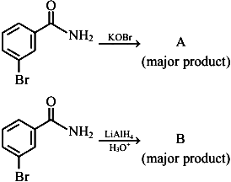the above reactions, product $A$ and product $B$ respectively are:

1. 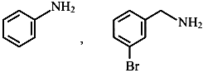
2. 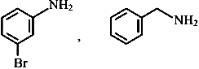
3. image
4. 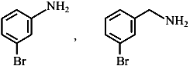

# Question 24

The product A formed in the following reaction is: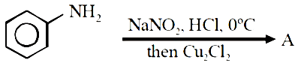

1. 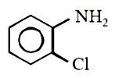
2. 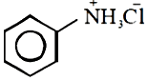
3. 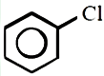
4. 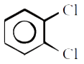

# Question 25

Number of compounds which give reaction with Hinsberg’s reagent is _______.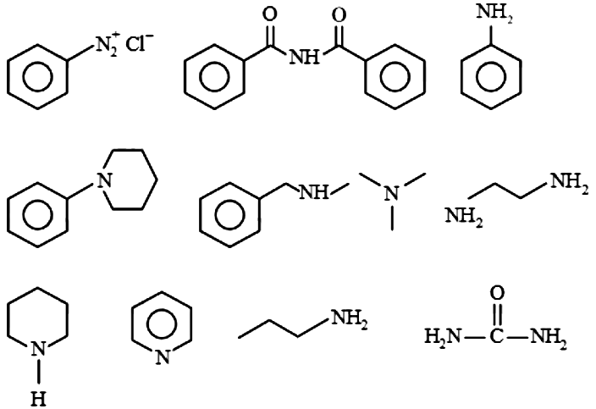

# Question 26

Given below are two statements :Statement I: Aniline reacts with con. $H_{2}{SO}_{4}$ followed by heating at $453-473 K$ gives p-aminobenzene sulphonic acid, which gives blood red colour in the ’Lassaigne’s test’.II: In Friedel - Craft’s alkylation and acylation reactions, aniline forms salt with the catalyst.to this, nitrogen of aniline aquires a positive charge and acts as deactivating group.the light of the above statements, choose the correct answer from the options given below :

1. Statement I is false but statement II is true
2. Both statement I and statement II are false
3. Statement I is true but statement II is false
4. Both statement I and statement II are true

# Question 27

In the reaction of hypobromite with amide, the carbonyl carbon is lost as

${CO}_{3}​^{2-}$

${HCO}_{3}​^{-}$

${CO}_{2}$

$CO$

# Question 28

Hydrolysis of which compound will give carbolic acid?

1. Cumene
2. Benzenediazonium chloride
3. Benzal chloride
4. Ethylene glycol ketal

# Question 29

A compound with molecular mass 180 is acylated with ${CH}_{3}COCl$ to get a compound with molecular mass 390 . The number of amino groups present per molecule of the former compound is:

# Question 30

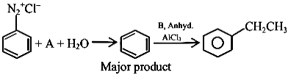the chemical reactions given above $A$ and $B$ respectively are:

1. $H_{3}{PO}_{2}$ and ${CH}_{3}{CH}_{2}Cl$
2. ${CH}_{3}{CH}_{2}OH$ and $H_{3}{PO}_{2}$
3. $H_{3}O_{2}$ and ${CH}_{3}{CH}_{2}OH$
4. ${CH}_{3}{CH}_{2}Cl$ and $H_{3}{PO}_{2}$

# Question 31

The total number of electrons around the nitrogen atom in amines are,

# Question 32

the above reactions, product $A$ and product $B$ respectively are:

1. 
2. 
3. image
4. 

# Question 33

The products A and B formed in the following reaction scheme are respectively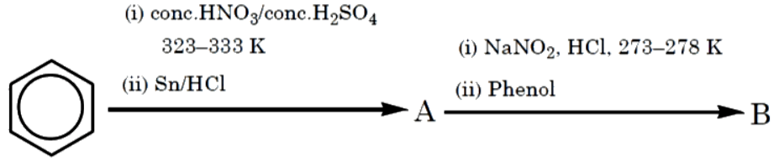

1. 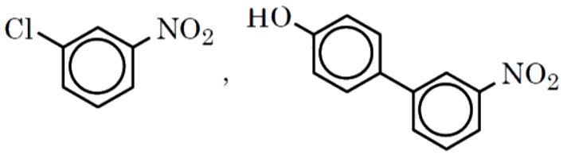
2. 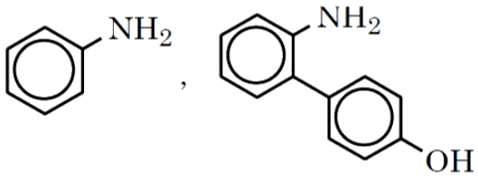
3. 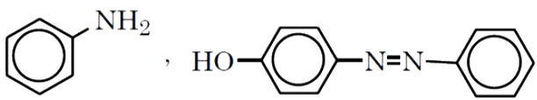
4. 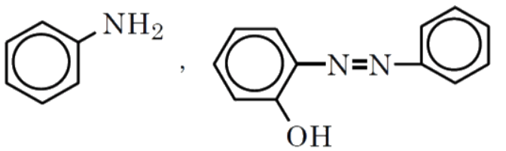

# Question 34

Which one of the products of the following reactions does not react with Hinsberg reagent to form sulphonamide? [25 Jul 2021]

1. 
2. 
3. 
4. 

# Question 35

A primary aliphatic amine on reaction with nitrous acid in cold ( $273 K)$ and there after raising temperature of reaction mixture to room temperature (298 K), gives.

1. nitrile
2. alcohol
3. diazonium salt
4. secondary amine

# Question 36

During halogen test, sodium fusion extract is boiled with concentrated ${HNO}_{3}$ to

1. remove unreacted sodium
2. decompose cyanide or sulphide of sodium
3. extract halogen from organic compound
4. maintain the $pH$ of extract.

# Question 37

the chemical reactions given above $A$ and $B$ respectively are:

1. $H_{3}{PO}_{2}$ and ${CH}_{3}{CH}_{2}Cl$
2. ${CH}_{3}{CH}_{2}OH$ and $H_{3}{PO}_{2}$
3. $H_{3}O_{2}$ and ${CH}_{3}{CH}_{2}OH$
4. ${CH}_{3}{CH}_{2}Cl$ and $H_{3}{PO}_{2}$

# Question 38

The number of primary amines of formula $C_{4}H_{11} N$ is ?